Ticket Management System

Landing Page:

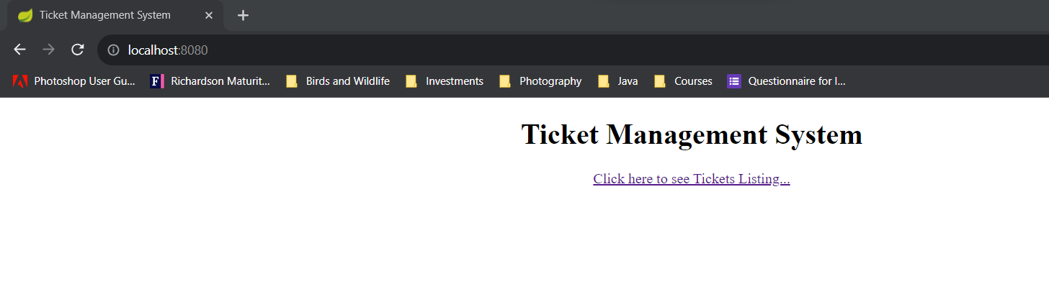

Click on the link provide on the landing page, to go to the Ticket Catalog

This page is having –

1. Ticket Listing
2. Add Ticket (at Header)
3. Ticket Search
4. Ticket Edit
5. Ticket Delete
6. Ticket View option

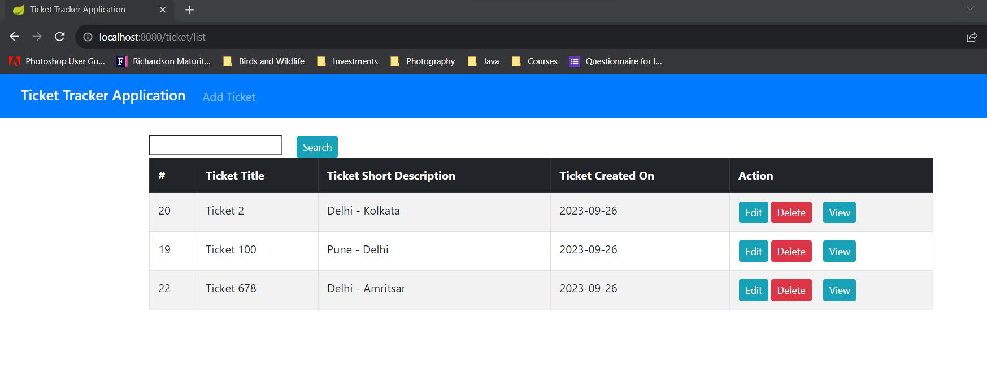

Search: can be done over Title and Description.

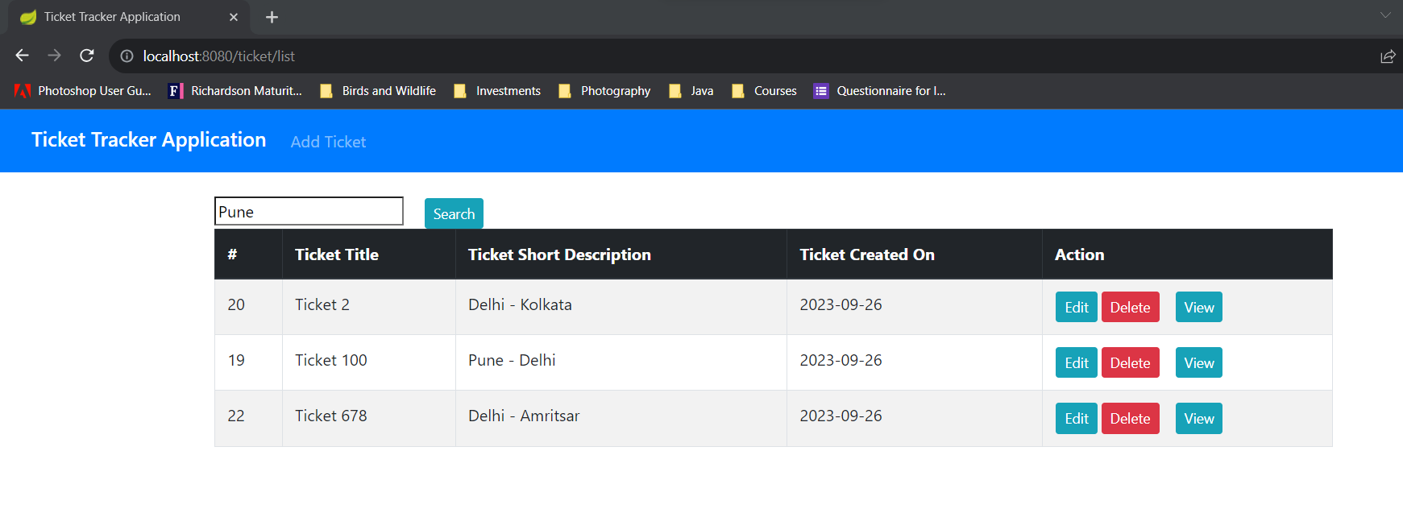

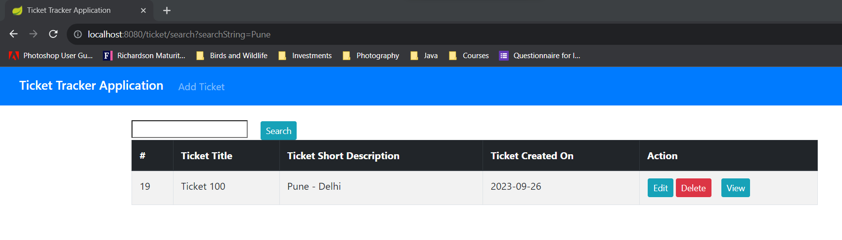

Also, searching with some test from Title, like –

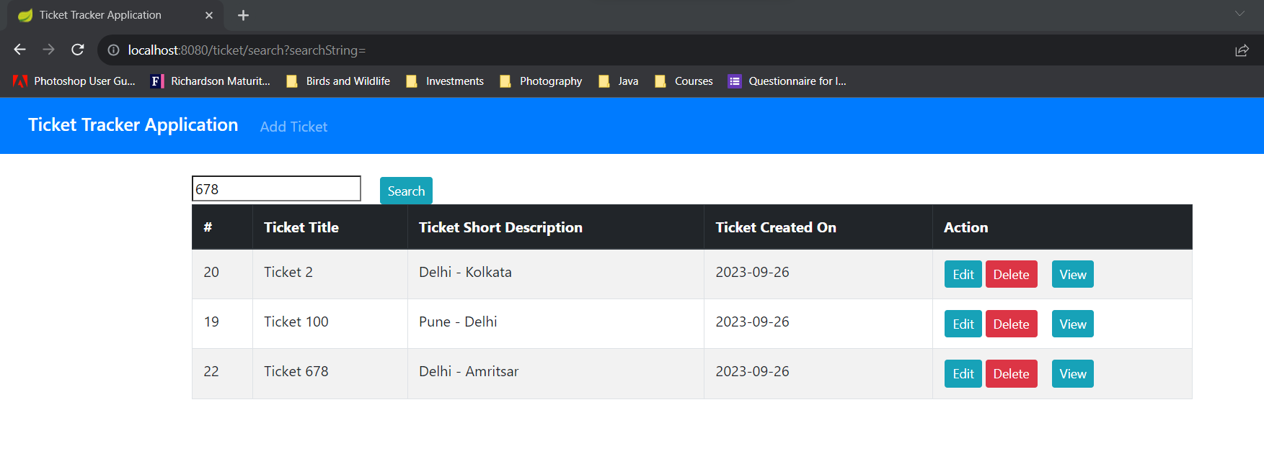

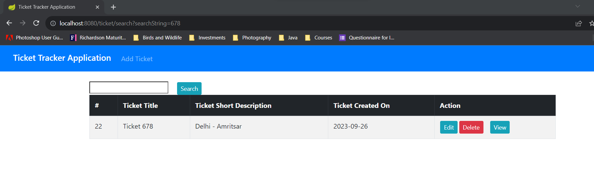

Blank criteria at search textbox, would return the all the results

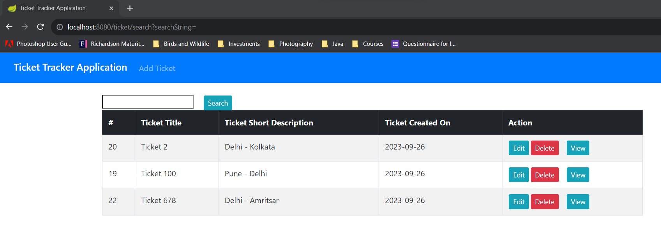

View existing Ticket: Select the View Button against any record

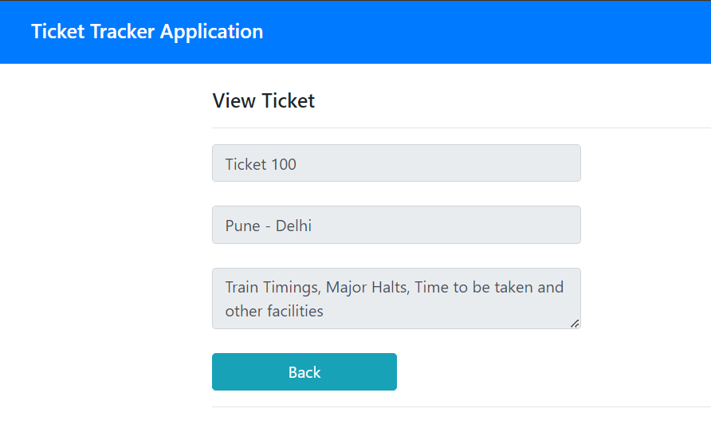

At View page, details could be viewed, but could not be edited

Edit Ticket: Select Edit Button against any record

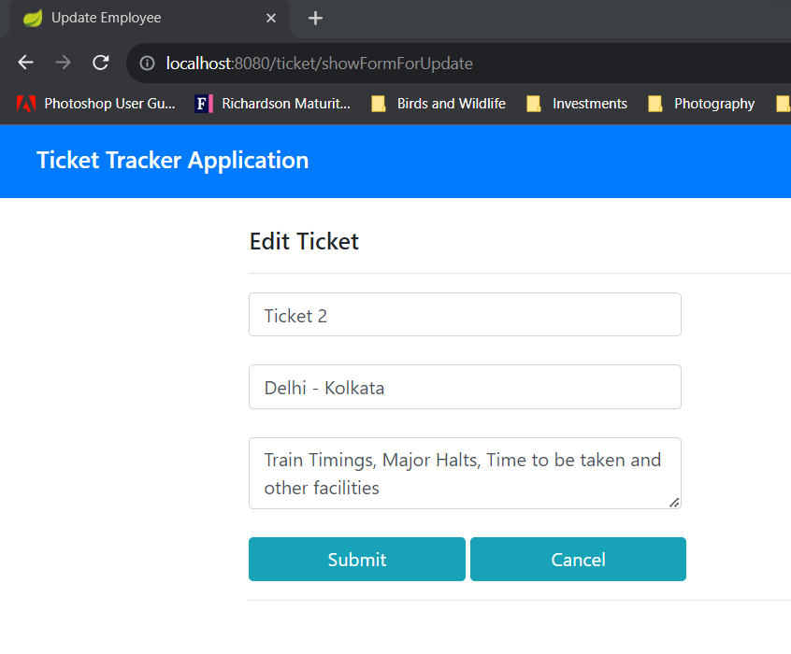

Updated the Ticket Title and submitted

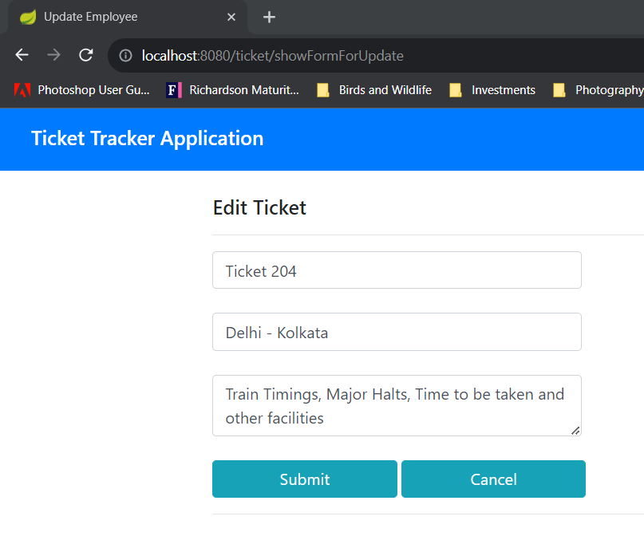

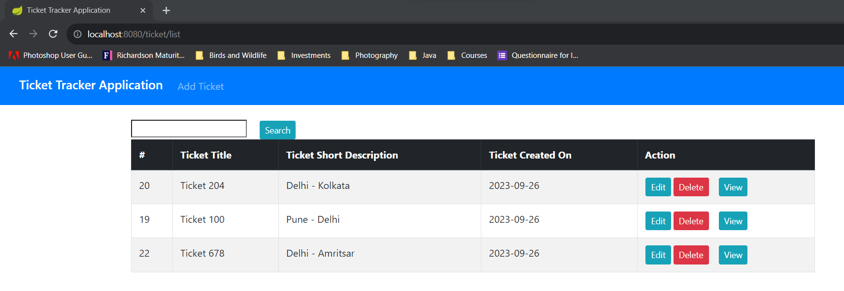

Add New Ticket: Can be done with the option provide at header.

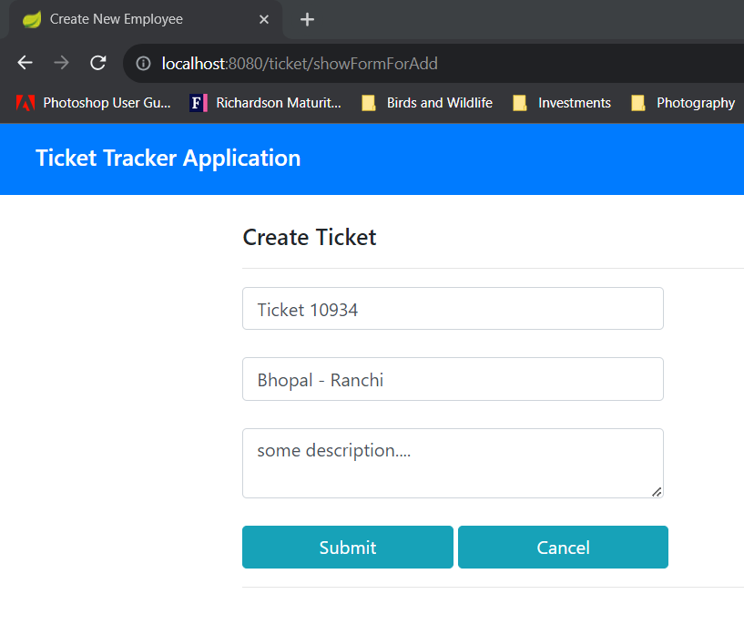

Click on submit, and the record could be seen at Ticket listing page

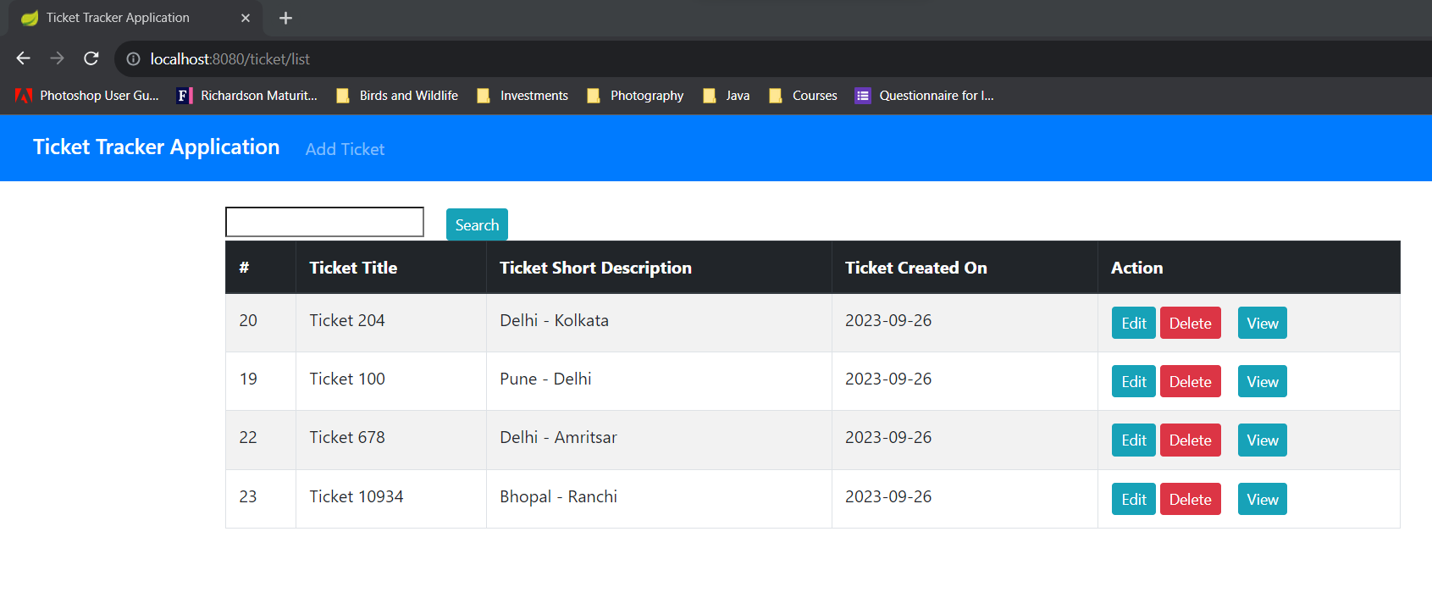

Deletion of the Ticket: Use the Delete button, against each record

Clicked Delete for ticket with Title = Ticket 100. System asking for confirmation.

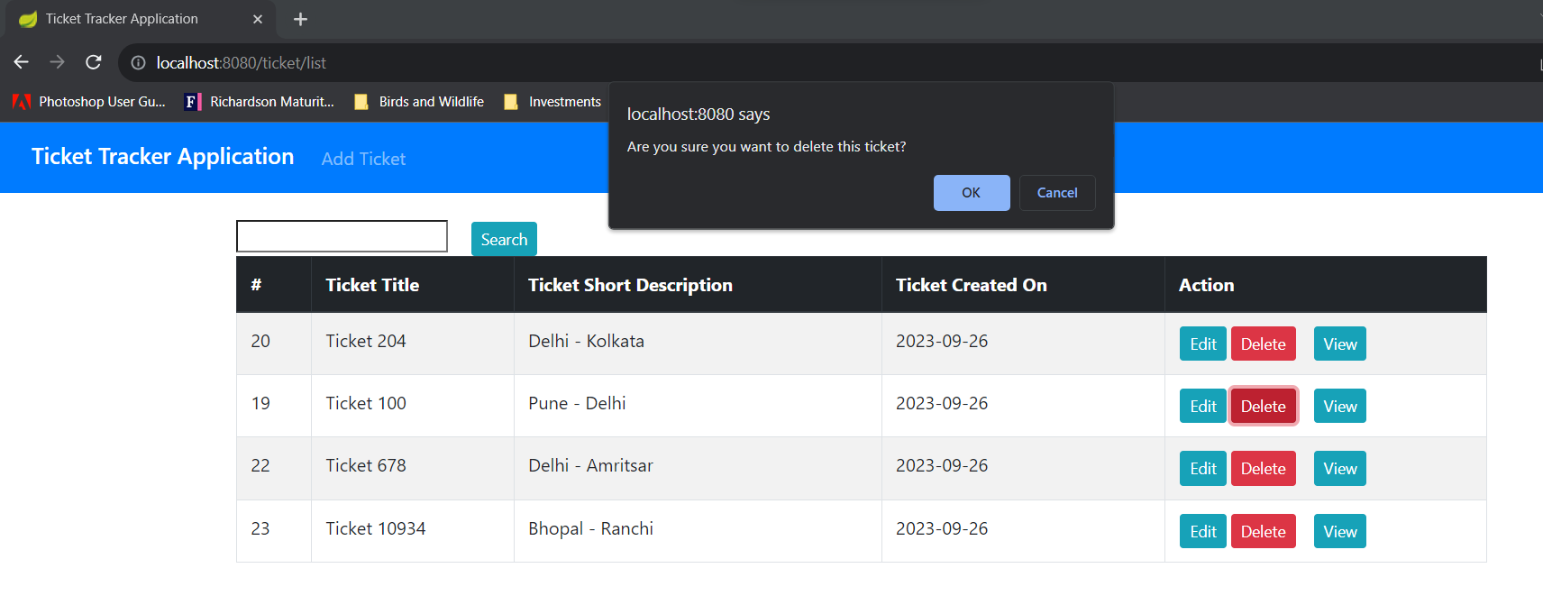

Clicked OK, and the ticket got deleted, could not be seen at listing.

